On Tuesday, 28 January, the Bangor University’s Shankland Library saw the launch of the book “Law and War in Popular Culture”. The book editor, Criminology Professor Stefan Machura from the School of History, Law and Social Sciences, talked about the portrayal of law and war in film in his introduction. He covered different contents and messages which are more varied than one might think. Then, Dr John Cunningham, Reader in Musicology, spoke about law and war in music. As main example, he referred to Mieczysław Weinberg’s opera “The Passenger”. The discussion afterwards, with interventions from Nathalie Thomas, French Language Tutor, and Meredith Levine, postgraduate student in criminology and criminal justice, touched on different experiences as expressed in film and television shows. The BBC series “SAS: Rogue Heroes” and its content featured in the exchange, as did the Punk movement. As a sign of the times, it ended up with thoughts on the uses of and manipulation by social media.
Book website: https://www.nomos-shop.de/en/p/law-and-war-in-popular-culture-gr-978-3-7560-0735-6. It is available in print and as e-book.
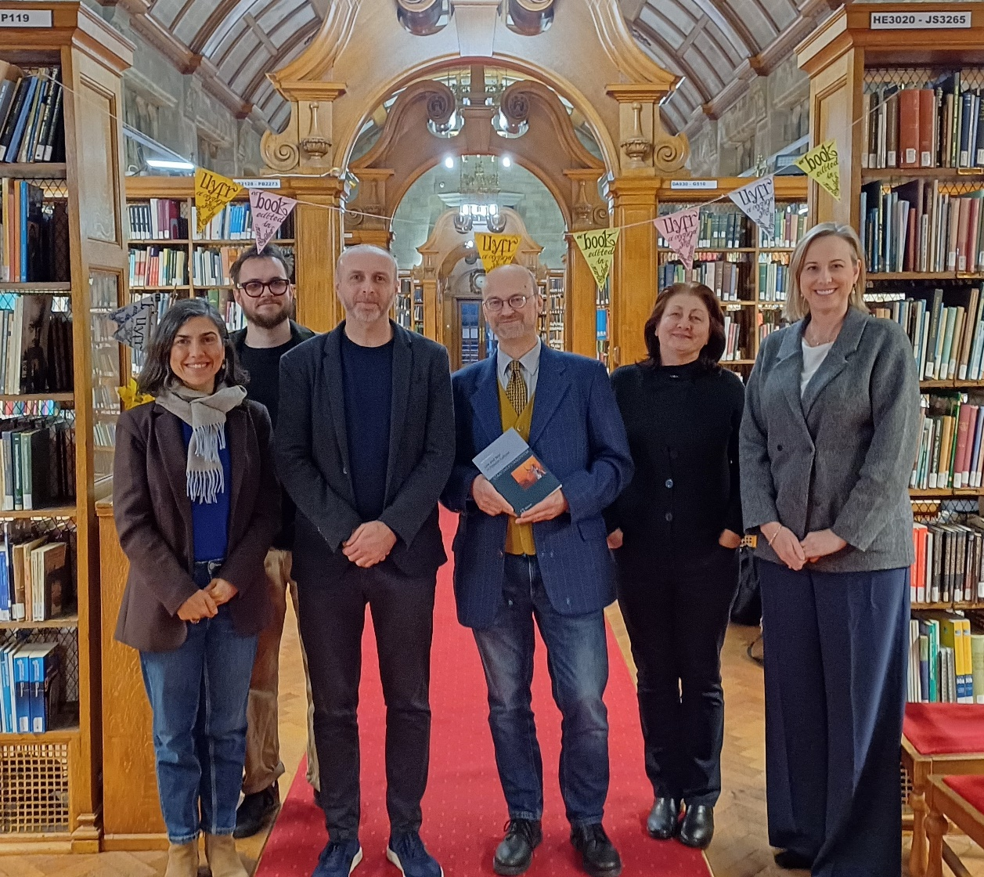
Ddydd Mawrth, 28 Ionawr, lansiwyd y llyfr “Law and War in Popular Culture” yn Llyfrgell Shankland Prifysgol Bangor. Soniodd golygydd y llyfr, yr Athro Stefan Machura o Ysgol Hanes, y Gyfraith a Gwyddorau Cymdeithas, am y portread o gyfraith a rhyfel mewn ffilm yn ei gyflwyniad. Rhoddodd sylw i wahanol gynnwys a negeseuon sy'n fwy amrywiol nag y gallai rhywun feddwl. Yna, siaradodd Dr John Cunningham, Darllenydd mewn Cerddoleg, am gyfraith a rhyfel mewn cerddoriaeth. Fel prif enghraifft, cyfeiriodd at opera Mieczysław Weinberg “The Passenger”. Roedd y drafodaeth wedyn, gydag ymyriadau gan Nathalie Thomas, Tiwtor Iaith Ffrangeg, a Meredith Levine, myfyrwraig ôl-raddedig mewn troseddeg a chyfiawnder troseddol, yn cyffwrdd â phrofiadau gwahanol fel y’u mynegir mewn rhaglenni ffilm a theledu. Roedd cyfres y BBC “SAS: Rogue Heroes” a’i chynnwys yn ymddangos yn y gyfnewidfa, fel y gwnaeth mudiad Punk. Fel arwydd o'r amseroedd, fe ddaeth i ben gyda meddyliau ar y defnydd o'r cyfryngau cymdeithasol a'u trin gan y cyfryngau cymdeithasol.
Gwefan archebu: https://www.nomos-shop.de/en/p/law-and-war-in-popular-culture-gr-978-3-7560-0735-6. Mae ar gael mewn print ac fel e-lyfr.

