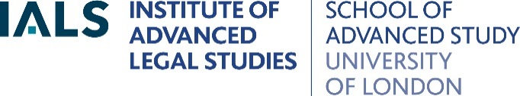

Call for a Volunteer to Join the IALS Library Committee

The Institute of Advanced Legal Studies, University of London (IALS) is seeking a volunteer to become one of the members representing UK law schools outside of the University of London on the IALS Library Committee. If you are an academic and interested in the national law collections and services provided by IALS Library and in representing the viewpoints of UK law researchers outside of the University of London, we would very much like to hear from you!

The role:
The members of the Library Committee are drawn from the law schools of the University of London, the law schools of the other UK universities, the British Library, the legal professions and the IALS student body. Their role is to advise the IALS Director, IALS Librarian and the IALS Advisory Council on all matters relating to the requirements and policy to be followed in the IALS Library, both in terms of the needs of the Institute as a national centre for legal research and study and in relation to the resources of other libraries. The IALS Library Committee meets online twice a year, usually in April and late October, and members are required to attend these meetings and participate in the discussions.

IALS Library:
IALS Library is the national research library for law. It offers academics and research students from the UK and abroad free access to over 300,000 legal texts, numerous foreign and international legal databases and eBooks, legal research training, and a number of focused legal research projects. It is one of the largest legal research libraries in Europe, and is particularly rich in the law of the UK, Commonwealth and European countries, the USA and EU, as well as foreign, international and comparative law. IALS also manages several legal archive collections. Further details about the national collections and services offered by IALS Library to UK legal researchers are available at: www.ials.sas.ac.uk/.

If you are eligible and interested in volunteering to join the IALS Library Committee in this role, please email a statement of up to 200 words describing your motivation for joining the Committee and submit a 2 page CV to Eliza Boudier at: eliza.boudier@sas.ac.uk.

The closing date for expressions of interest is 28th February 2025.

