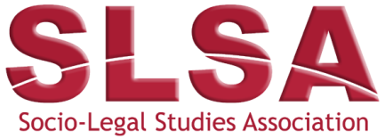 | Hart Socio-Legal Article Prize 2024

This form, along with a copy of the article, should be submitted to admin@slsa.ac.uk prior to the advertised closing date and including a copy of an email from nominee agreeing to their nomination.

This form can be completed using Word. Click on the grey boxes and type your answers. When the form is complete please save it using a filename in the following format:
[Lead Author’s Last Name]_[Short Title of the Article].docx

Note: the nominee and the nominators must both be fully paid up or free registered postgraduate members of the Socio-Legal Studies Association.

Author(s):
Author(s) SLSA Contact IDs:

Lead Author’s Email:

Full article citation:

Date the article was published (month and year):

Please provide a statement of less than 200-words explaining why the nominated article is socio-legal:

Author(s) Agreement:
I/We, (insert name of author(s)), agree to my/our article (see above) being nominated for the Hart Socio-Legal Article Prize.

